QUESTION – 1

$$f_{1}\left(7\right)=c_{0}+c_{1}7=98$$

$$f_{1}\left(14\right)=c_{0}+c_{1}14=101$$

$$\left[\begin{matrix}1 & 7 \\ 1 & 14\end{matrix}\right]\left[\begin{matrix}c_{0} \\ c_{1}\end{matrix}\right]=\left[\begin{matrix}98 \\ 101\end{matrix}\right]→\left[\begin{matrix}c_{0} \\ c_{1}\end{matrix}\right]={\left[\begin{matrix}1 & 7 \\ 1 & 14\end{matrix}\right]}^{-1}\left[\begin{matrix}98 \\ 101\end{matrix}\right]=\left[\begin{matrix}95 \\ 0.4286\end{matrix}\right]$$

$$f_{1}\left(x\right)=95+0.4286x$$

$$f_{1}\left(12\right)=95+0.4286*12=100.1432$$

$$f_{2}\left(0\right)=c_{0}=100$$

$$f_{2}\left(7\right)=c_{0}+c_{1}7+c_{2}7^{2}=98$$

$$f_{2}\left(14\right)=c_{0}+c_{1}14+c_{2}{14}^{2}=101$$

$$\left[\begin{matrix}1 & 0 & 0 \\ 1 & 7 & 7^{2} \\ 1 & 14 & {14}^{2}\end{matrix}\right]\left[\begin{matrix}c_{0} \\ c_{1} \\ c_{2}\end{matrix}\right]=\left[\begin{matrix}100 \\ 98 \\ 101\end{matrix}\right]→\left[\begin{matrix}c_{0} \\ c_{1} \\ c_{2}\end{matrix}\right]={\left[\begin{matrix}1 & 0 & 0 \\ 1 & 7 & 7^{2} \\ 1 & 14 & {14}^{2}\end{matrix}\right]}^{-1}\left[\begin{matrix}100 \\ 98 \\ 101\end{matrix}\right]=\left[\begin{matrix}100 \\ -0.6429 \\ 0.0510\end{matrix}\right]$$

$$f_{2}\left(x\right)=100-0.6429x+0.0510x^{2}$$

$$f_{2}\left(12\right)=100-0.6429×12+0.0510×{12}^{2} = 99.6292$$

$$f_{3}\left(21\right)=c_{0} + c_1 21 + c_2 ^2=50$$

$$f_{3}\left(7\right)=c_{0}+c_{1}7+c_{2}7^{2}=98$$

$$f_{3\left(14\right)}=c_{0}+c_{1}14+c_{2}{14}^{2}=101$$

$$\left[\begin{matrix}1 & 21 & {21}^{2} \\ 1 & 7 & 7^{2} \\ 1 & 14 & {14}^{2}\end{matrix}\right]\left[\begin{matrix}c_{0} \\ c_{1} \\ c_{2}\end{matrix}\right]=\left[\begin{matrix}50 \\ 98 \\ 101\end{matrix}\right]→\left[\begin{matrix}c_{0} \\ c_{1} \\ c_{2}\end{matrix}\right]={\left[\begin{matrix}1 & 21 & {21}^{2} \\ 1 & 7 & 7^{2} \\ 1 & 14 & {14}^{2}\end{matrix}\right]}^{-1}\left[\begin{matrix}50 \\ 98 \\ 101\end{matrix}\right]=\left[\begin{matrix}41 \\ 12 \\ -0.5510\end{matrix}\right]$$

$$f_{3}\left(x\right)=41+12x-0.5510x^{2}$$

$$f_{3}\left(12\right)=41+12×12-0.5510×{12}^{2} = 105.656$$

I think the $f_{3}$ is the best choice, since it also results better for other data points which means it is much closer to giving the real at point x =12 than the others.

QUESTION – 3

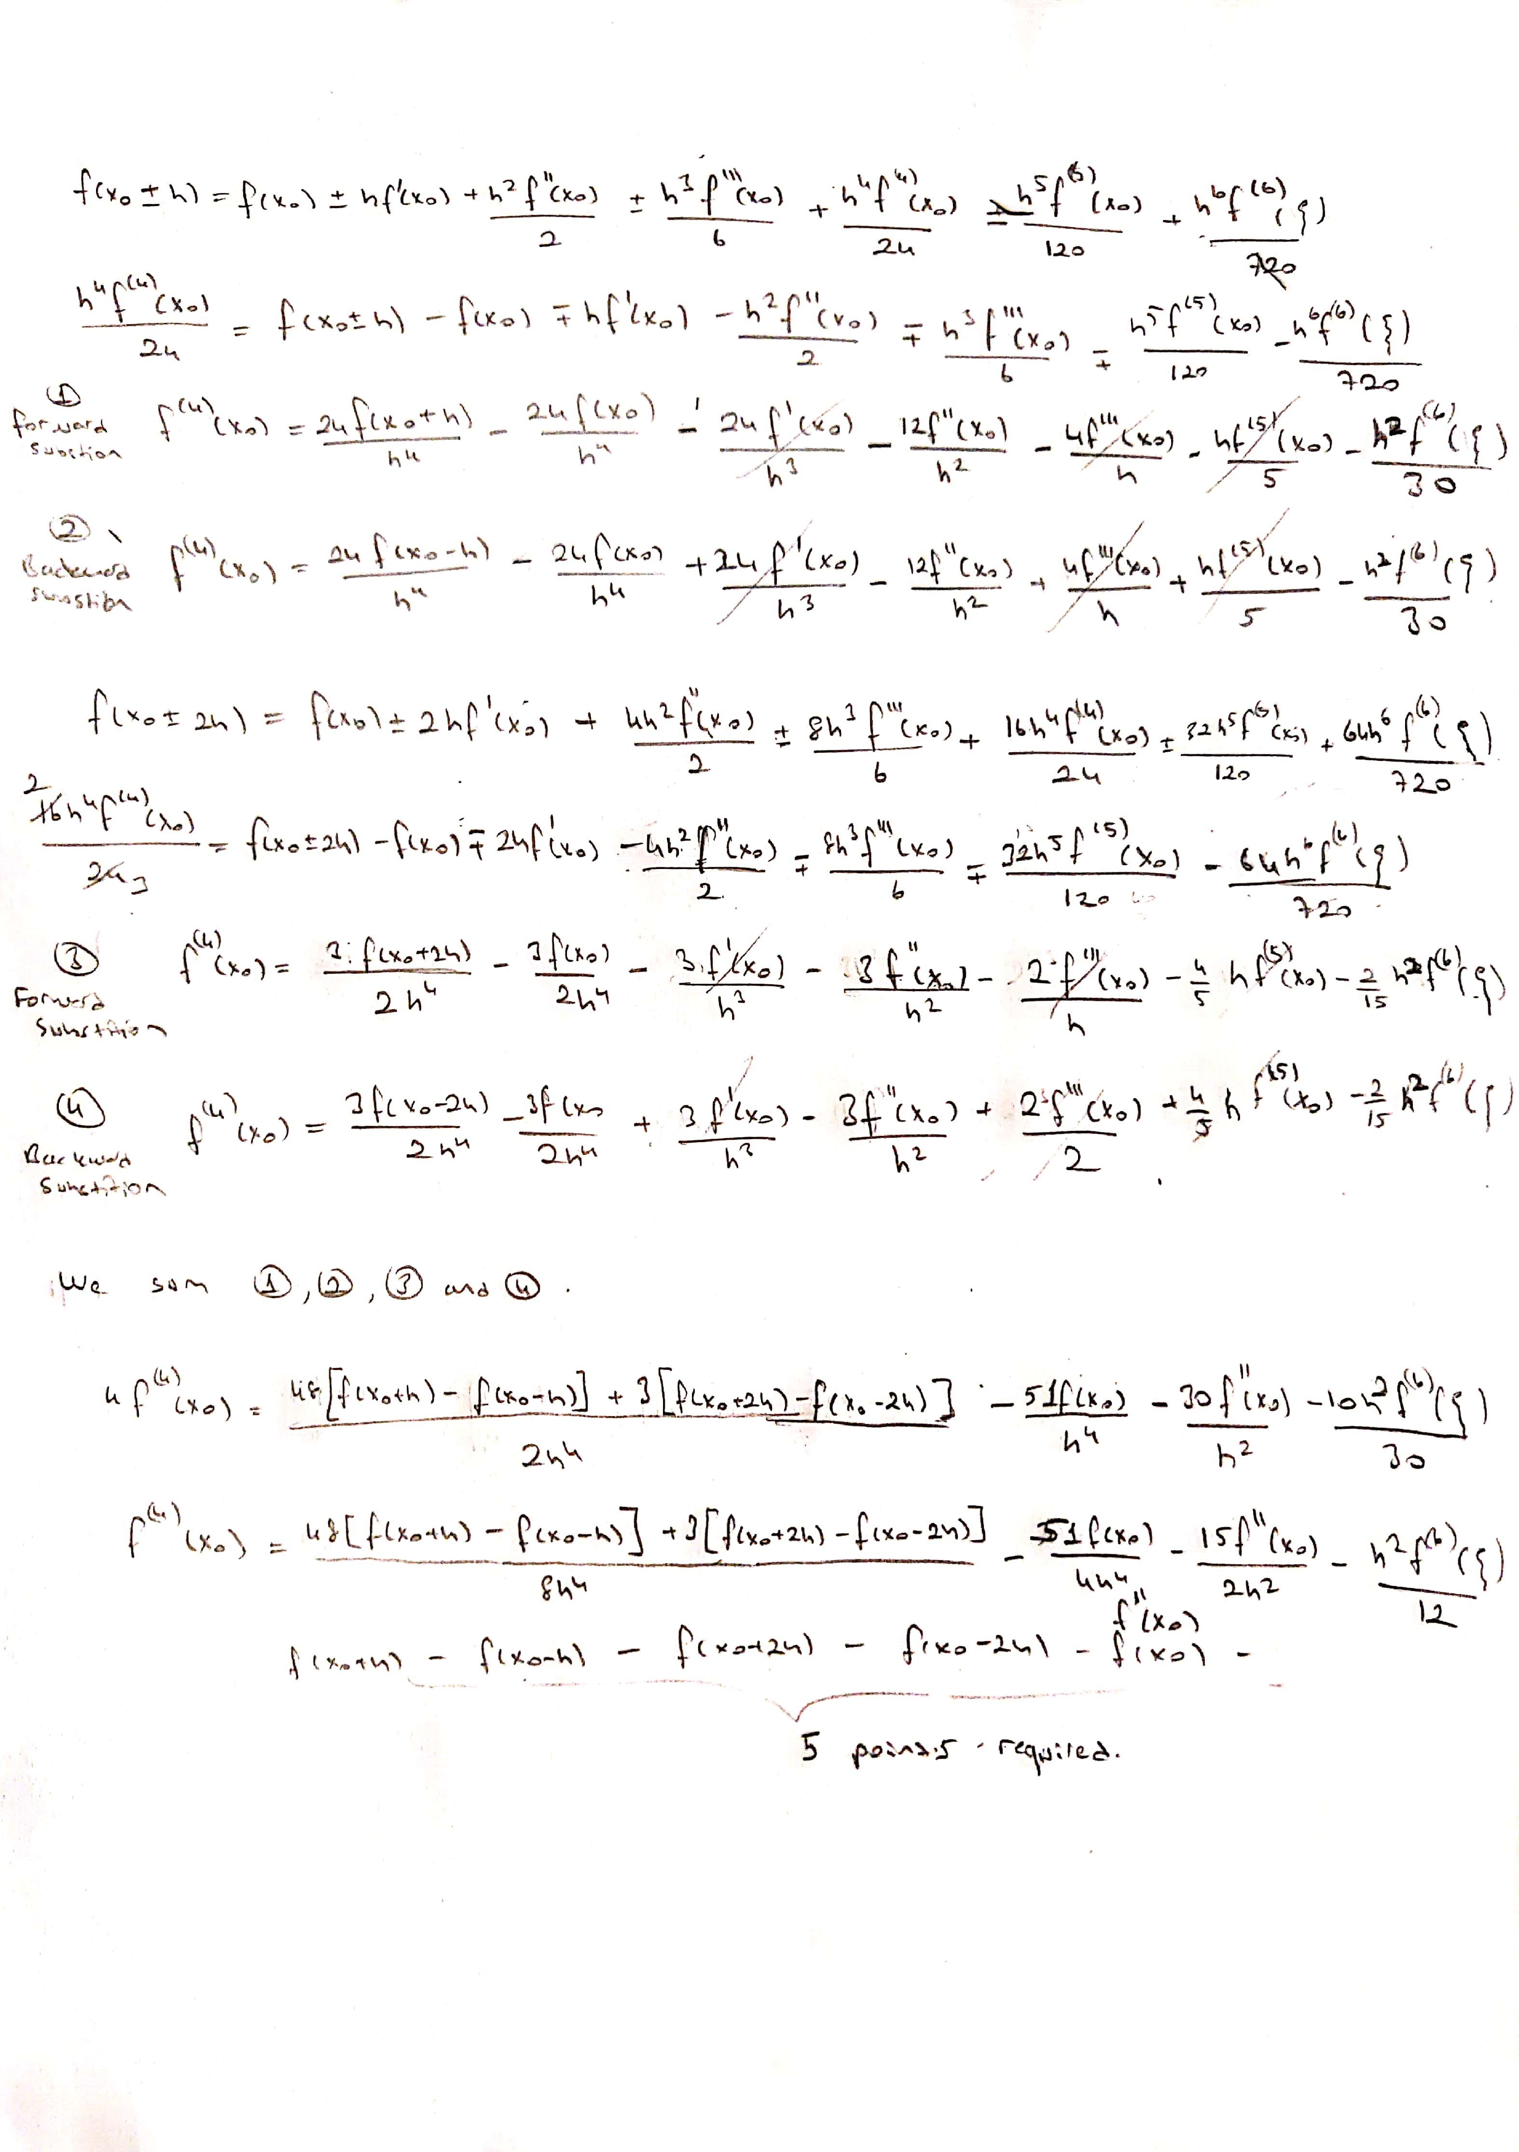

As it can be seen from the last term, order of the formula is $O\left(h^{2}\right)$.

QUESTION – 4

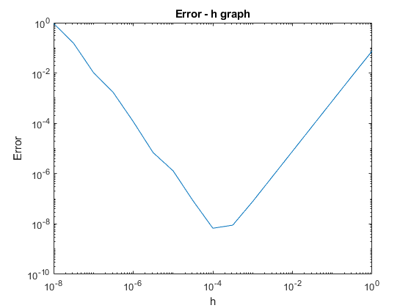

As h decreases, error decreases until the point at ${10}^{-4}$ after that error starts to increase because of the roundoff error.

Optimal h is ${10}^{-4}$ which is the lowest point on the graph which has lowest error.